**Task-07 Screenshots**

**Q1.Write a Java program that reads user input for two integers and performs division.Handle the exception that is thrown when the second is zero and display an error to the user.**

**Q1.Program and Output-1**

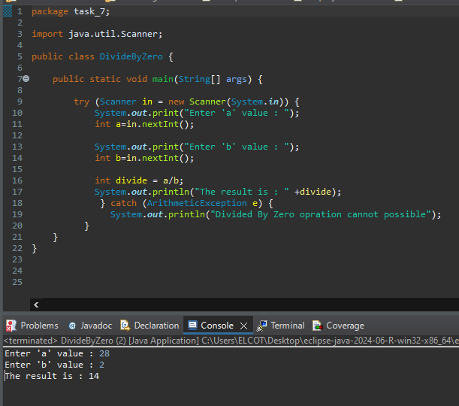

**Q1.Program and Output-2**

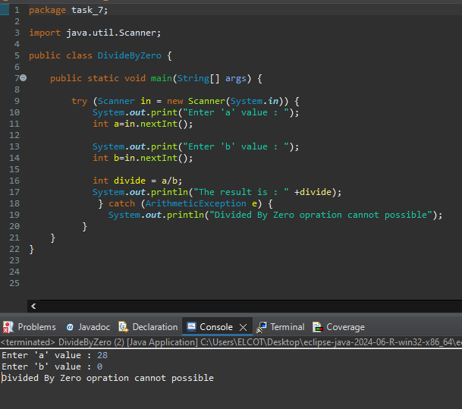

**Q2.ArrayIndexOutOfBoundsException**

**Program and Output-1**

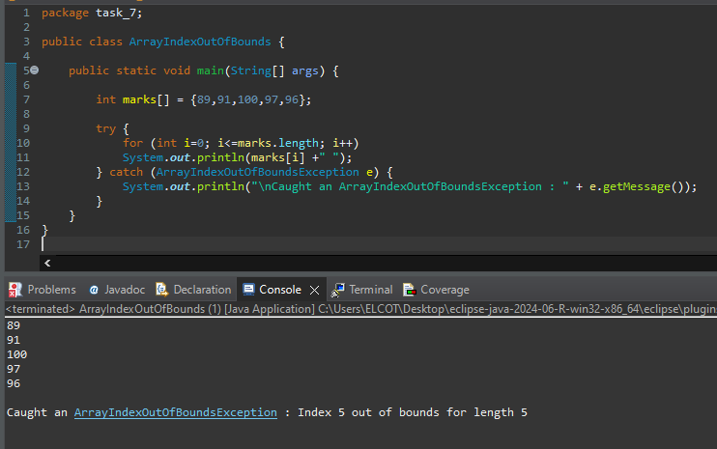

**Q2.Program and Output-2**

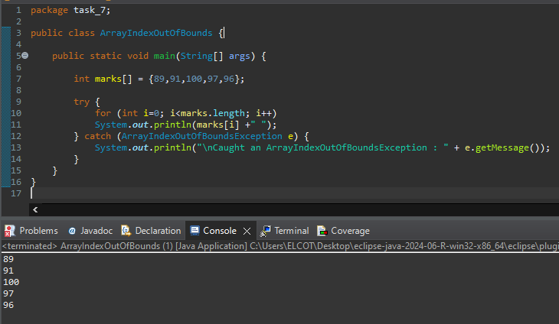

**Q2.StringIndexOutOfFoundException**

**Program & Output-1**

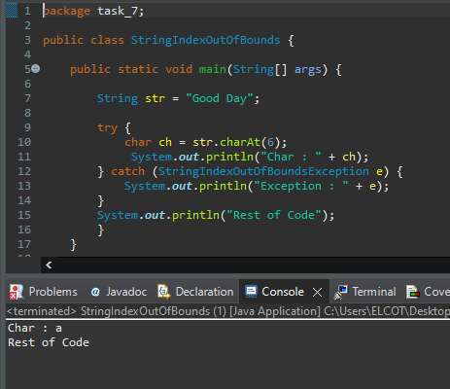

**Program & Output-2**

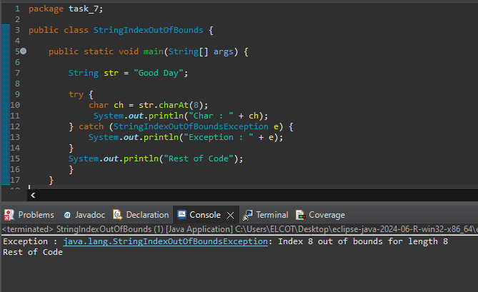

**Q3.InValidAgeException**

**Program & Output-1**

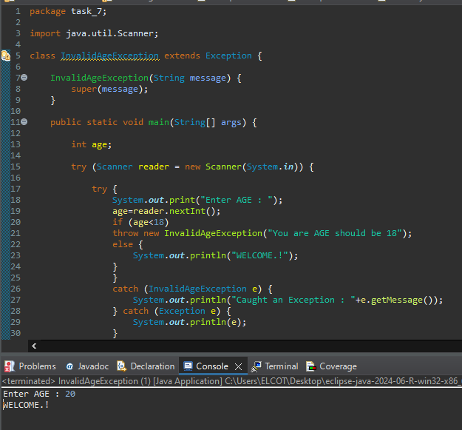

**Q3.Program & Output-2**

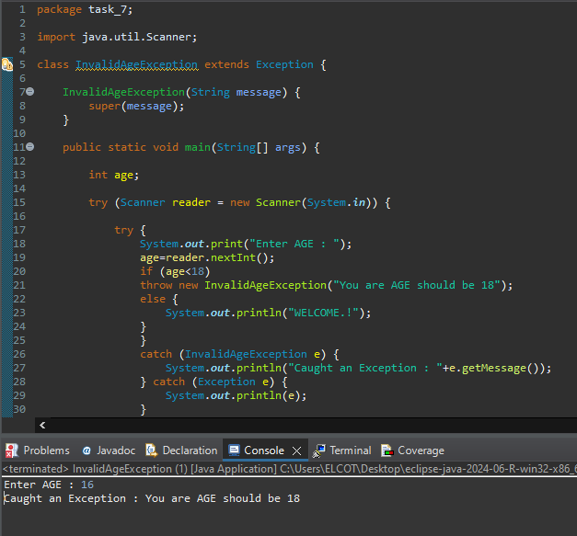

**Q4.FileNotFoundException**

**Program**

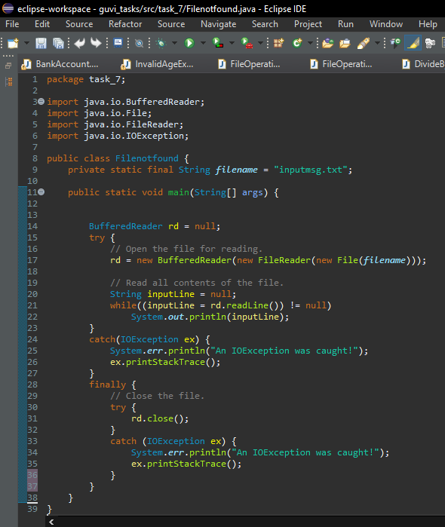

**Q4.Output**

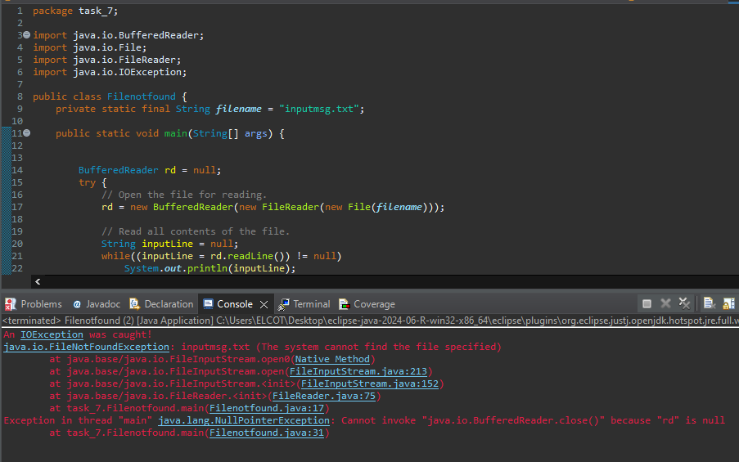

**Q5.Remove all elements from ArrayList**

**Program & Output**

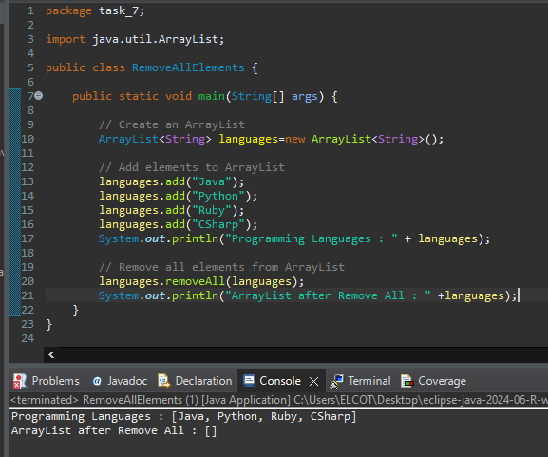

**Q6.Employee details with name-alphabetical order**

**Program**

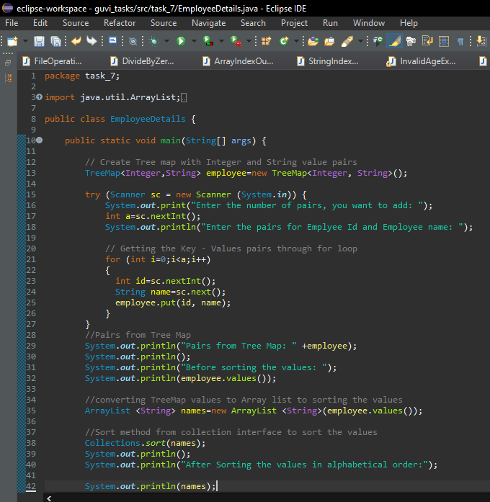

**Q6.Output**

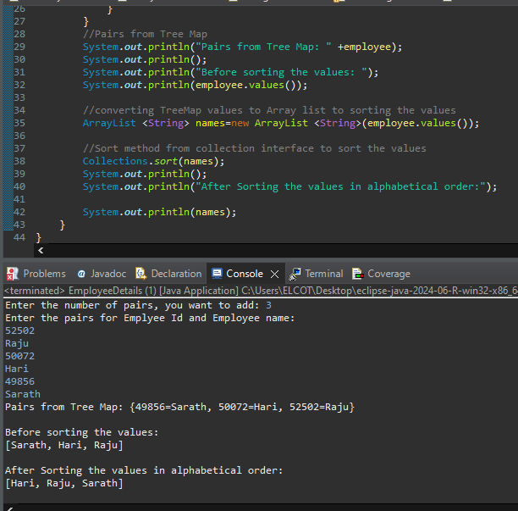

**Q7.Convert List to Array**

**Program**

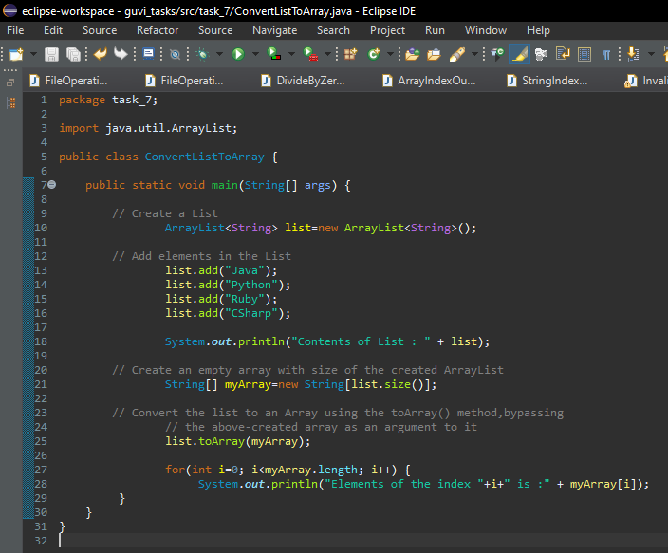

**Q7.Output**

